Sam Lee’s Team

CSC-131

4/22/2019

HW 5 – Use Case

Part I:

Diagram A:

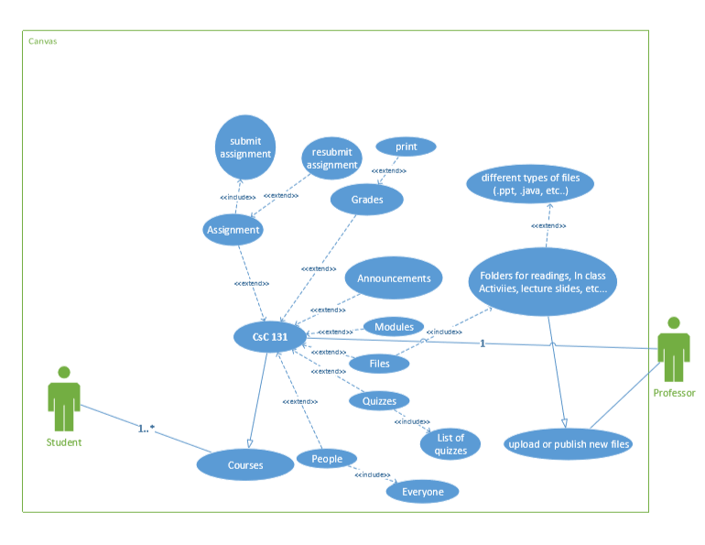

Diagram B:

Part II: Use Case Scenario 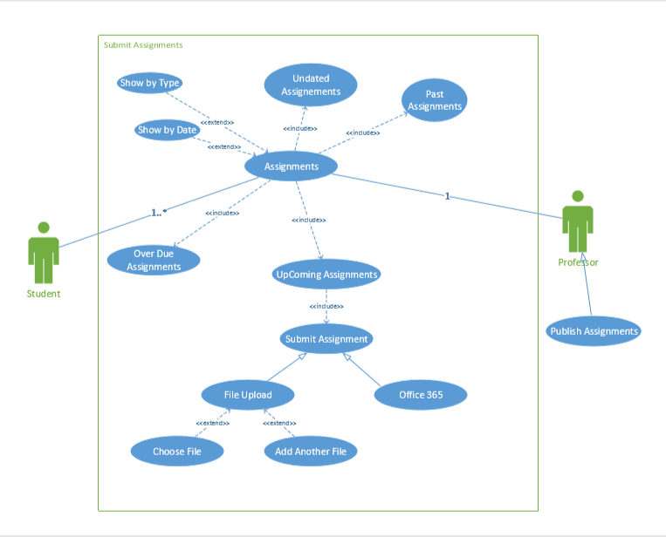

Use Case Name: **Grades**

Actors: **Students, TA, Professor**

Stakeholders and Needs:

* Provides up to date grades published by either the TA or the professor
* Must have the title of the assignment graded along with the published grade
* Must have a total percentage or the course grade listed anywhere on top of the page

Preconditions:

* Course for which is grade is being viewed should be listed
* Name of the user aka student should be listed
* All the separate categories that contribute to the total grade should be included

Post Conditions:

* A tab for selecting the course grade that a student wants to view
* A tab for arranging how the student wants to view their grade. i.e. (by due date, title, module, or assignment group)
* Student should be notified to check their grade

Trigger:

Either the TA or Professor publishes a grade which the student wants to view, or a grade change occurs which the student wants to view.

Basic Flow:

1. A grade is published
2. The student is notified
3. The student checks the grade
4. If there is a mistake, an option to modify and change the grade will be implemented by the TA or the professor
5. The grade is updated
6. Student checks and verifies corrected grade

Extension:

* A button for “Show what-if scenario” as well as “revert to actual score”.
* A button to show all details for all the grades posted as well as close all details
* A button to print the listed grades

Part III: Interaction Design Principles